Whatipu cave's buried dance floor reveals forgotten history
Eva Corlett10:47, Dec 17 2015
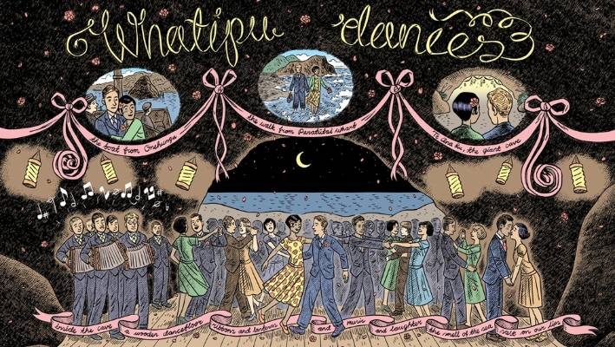
DYLAN HORROCKS
The former Waitakere CIty Council comissioned a mural from renowned cartoonist Dylan Horrocks, depicting the dances held in Te Ana Ru cave.
A cave could be considered an unusual choice of venue for a ball.
But buried beneath five metres of shifting sands in a cave on one of Auckland wildest west coast beaches, lies a kauri ballroom dance floor.
For more than 60 years, from 1899 onwards, party-goers trekked across the rugged Whatipu coastline to Te Ana Ru cave to mince across the lamp-lit floor and steal away into dark corners.
Whatipu is remote, so much so that only in November 2015 did the area get patchy cell phone coverage for the first time.
Dirt roads snake along the coastline through what feels like primeval native bush, until you reach the expansive shores and thunderous sea.
The recorded history of the dances is scattered and small, with only a few letters and hand me-down stories indicating their existence.No doubt there are many tales buried with the dance floor, and photographs tucked into forgotten pockets.
In a letter dated 1901 to a newspaper column called Dear Dot, a girl by the initials E.D.N.A. writes: "A short distance round our beach are some very large caves; one is so large in fact, that my brothers put a floor in it, so that we could be able to have a dance."
Whatipu Lodge owner Wayne McKenzie believes the letter-writer was a member of the Gibbons family.
E.D.N.A. goes on to describe the cave.
"I suppose you will smile at the idea of dancing in a cave," she says.
"But when it is lit up with coloured lamps and decorated with ferns it looks better than any ballroom."
Barbara McKenzie, mother of the current Whatipu Lodge owner Wayne McKenzie, attended a school fundraiser ball there in 1973.
She remembers driving in a 4WD convoy and having a fun night.
Huia Settlers Museum trustee Lee Bullinga says his mother attended the same dance.
"I remember seeing my mother all dressed for a ball while wearing tennis shoes with galoshes over the top," Bullinga says.
"Inside a duffle bag was her evening purse and dancing shoes to be put on when they arrived."
In more recent times the cave has been used as a recording studio and 90's rave venue.
But for now, the dances remain an eccentric echo of the past.
A brief Whatipu history
Te Ana Ru cave is in Whatipu about 40 kilometres from Auckland's city centre.
Whatipu was originally settled by Maori around 1200AD with some of the earliest ancestors being the Turehu people.
Now, the area is affiliated with the iwi Te Kawerau a Maki.
In later years, the area became a major kauri milling hub, which was set up by the Gibbons family.
After setting up mills in nearby Huia, they moved sites to Whatipu and were in operation by 1868.
A homestead, now known as Whatipu Lodge, was subsequently built and remains an important landmark in the area.
Whatipu is also famous for what is New Zealand's worst maritime disaster to date.
The HMS Orpheus sunk in 1863, killing 189 crew and passengers on board.
The region is home to an abundance of native wildlife and is now a Scientific Reserve, managed by Auckland Council and the Department of Conservation.
Stuff

